

**3M™ AVERAGE SPEED CAMERA SYSTEM**

**VR-VIEWER**

**USER MANUAL ISSUE 2.1**

**AMENDMENT RECORD**

|  |  |  |
| --- | --- | --- |
| ISSUE | DATE | BRIEF DETAILS OF CHANGE |
| 1.3 | 17/07/2009 | Initial release, with dual context image hard-copy |
| 1.4 | 04/08/2009 | VR updated to reflect HOSDB comments |
| 1.5 | 26/05/2010 | Some screenshots update |
| 2.0 | 26/07/2013 | Remove some unrelated functions Update to 3M nomenclature for products |
| 2.1 | 19/02/2014 | Minor changes of some words after internal review |
|  |  |  |
|  |  |  |
|  |  |  |
|  |  |  |

The overall issue status of this document is the latest issue shown in the table above. Author: Qifeng Huang, Brian Smith

**TABLE OF CONTENTS**

1. Getting Started 4
2. Search Violations 6
   1. Refresh/Reload Violation List 6
   2. Violation Details 7
   3. HTML Export 8
3. Time Synchronization Records 10

3 Change Key Store 11

Appendix 1: Configurations in VR-Viewer 12

Appendix 2: HardCopy example directly imported into Microsoft Word ( VRN’s anonymised)

............................................................................................................................................. 13

# Getting Started

The 3M™ Average Speed Camera System produces a collection of violation records (VRs) written to CD-ROM. The VR-Viewer is a stand-alone utility, which can be run on a back office PC or on a laptop e.g. to be taken to the court for presentation of the evidence. The VR- Viewer provides a GUI for the review of all aspects of violation records. Its main functions are:

* + Load, list, sort, navigate and search violations from a VRs CD
  + Display details of a violation
  + Export violation details to file system in HTML format for hard-copy purposes or for incorporation into other documents
  + Display of outstation time synchronization records
  + Load and update of system security key store

Usually a dongle is required to run the VR-Viewer. When running a release of VR-Viewer not protected by a dongle, the pass phrase for accessing the VR-Viewer key store must be provided when prompted when VR-Viewer starts. Because violations are written as authenticated and encrypted records to CD on the ERCU, the corresponding key store is required to open and view them in VR-Viewer. If no key store has been loaded previously; such as when this is the first time the VR-Viewer program has been run, then it is necessary to load the VR-Viewer key store as shown in Figure 1 and Figure 2. To do this the key store CD which has been generated by the Key Manager (KM) is required. In addition to the CD a pass phrase is required in order to access the key store.

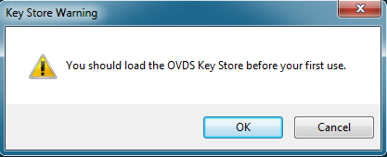

**Figure 1: VR-Viewer Load Key Store Prompt**

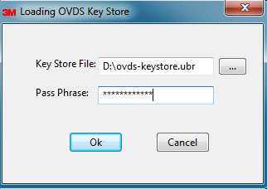

**Figure 2: Load VR-Viewer Key Store**

During start-up, VR-Viewer will automatically load the encrypted violation records from one of the configured CD/DVD drives. It may take up to several minutes to load all the violations, but whilst this is happening details of the violations already loaded may be accessed. A summary screen of all violations is presented for the review of the primary evidence of the offences in the format of a table, as shown in Figure 3. It is possible to order all or some of loaded violations by offence time, VRN, primary speed, secondary speed, link name, source and target camera site ID, or corresponding link calibration certificate ID. All related functions mentioned below are accessible through the upper menus, with shortcut buttons for some of the common operations.

It is recommended that the violation CD is kept in the CD drive all the time. It may otherwise be necessary to insert this CD during the following operations . It is also possible to review violations on another CD without restarting the tool.

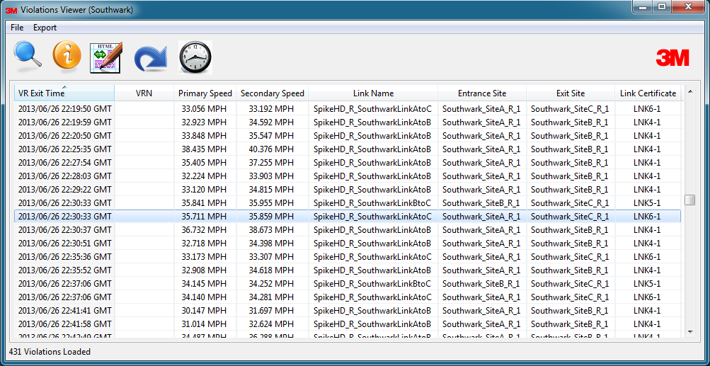

**Figure 3: VR-Viewer Summary Review**

# Search Violations

Thousands of violations could be contained in a CD and shown on the screen. The multi- criteria search function can help to narrow down this size and ease the review. As shown in figure 4, it is possible to search violations based on one or more of following conditions:

* + Violated link selected from a drop-down list
  + Plate number: support wildcards “?” for any character and “*” for substring including none. Leave it blank if matching all plates
  + Minimum violated speed: leave it blank for all violated speed
  + Time period when the violations happened: zero time gap will match any violated time

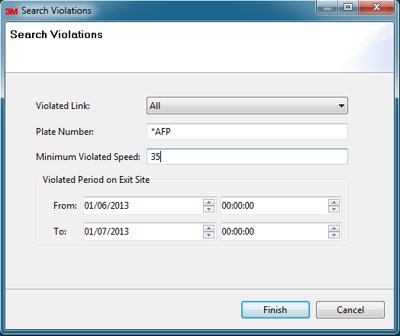

**Figure 4: Search Violations**

If there are matched violations, they will be then listed in the summary table, otherwise an error message will be shown.

## *Refresh/Reload Violation List*

It may be necessary to refresh or reload the violation list by clicking the “Refresh” menu item or action button whenever:Restoring the full list of all violations after a search operation.

* + - The violation CD is changed and the contents of the violation list from the inserted CD needs to be displayed.

## *Violation Details*

The detailed evidence of a selected violation can be displayed in a new window through corresponding menu/button operation or mouse double click, as shown in Figure 5. On the top-right part of the window, the patch images are visible as well as the thumbnails for infra- red and overview images related to a violation, from both entrance and exit cameras. Thumbnails for up to 8 context images, if existent, will be also displayed in this part. Clicking on any thumbnail will display the full high resolution version in the right-bottom part of the window.

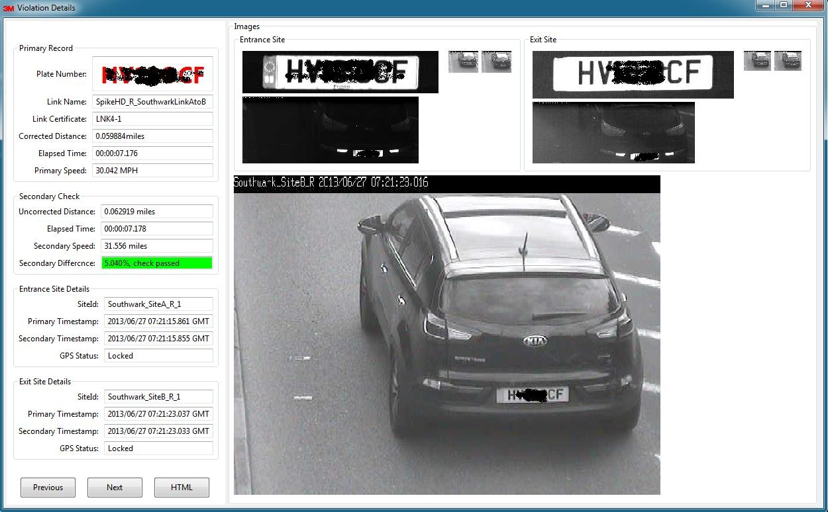

**Figure 5: Violation Details**

Navigation amongst multiple selected violations or all violations shown in the summary table in this window is also available by clicking the “Previous”/“Next” buttons, or pressing page up, page down, home, end and various arrow keys on the keyboard.

Alternatively, it is possible to show the violation details in a pop-up window in the format of HTML, as shown in Figure 6. There is also an option to save the details as an HTML file or print it by selecting the appropriate function from right mouse menu.

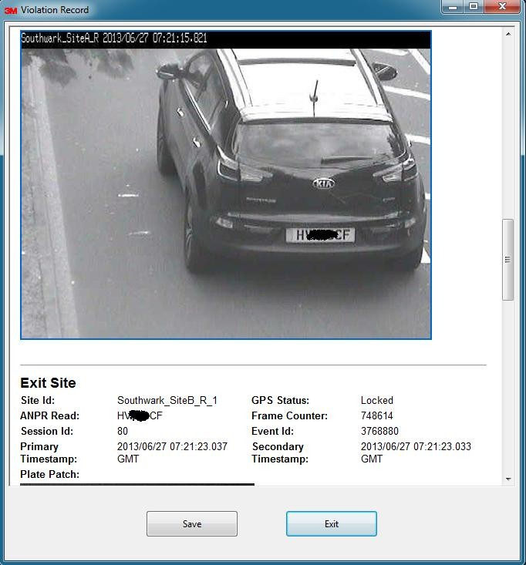

## *HTML Export*

**Figure 6: Violation Details in HTML Format**

Violation records can be exported to file system in HTML format and separate image files (please note this feature may not be available for some releases). The violations to export must be selected and the export destination defined as shown in figure 7. Results are displayed in a pop-up new window after the operation finishes, as shown in Figure 8. Violations can be selected for display from the drop-down list at the top.

It may take some time to finish this operation when the number of violations being exported is large (even hours if exporting hundreds of thousands violations at a time). The exported HTML file may be directly imported into Microsoft Word using the ‘insert file’ command as illustrated in Appendix 2.

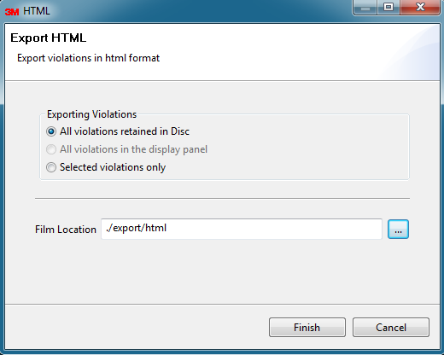

**Figure 7: Export Violations to HTML**

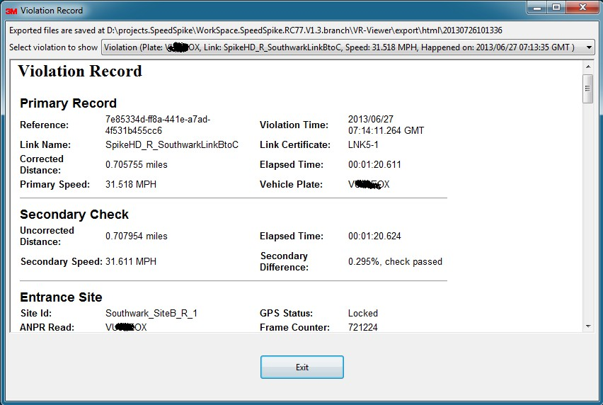

**Figure 8: Exported Violations (HTML)**

# 3 Time Synchronization Records

VRs and associated time synchronization records are recorded on the same evidential CD- ROM. The VR-Viewer provides a menu/button operation to present all time synchronization records as shown in Figure 9. Each synchronization record is for an enforcement network with one or more links and many cameras. The GUI shows the synchronization time and its result status for each record for the enforcement network. Moreover, for each camera, it is possible to see when the time synchronization message was received, the primary and secondary timestamps of the camera, and the result status of the time synchronization for this camera.

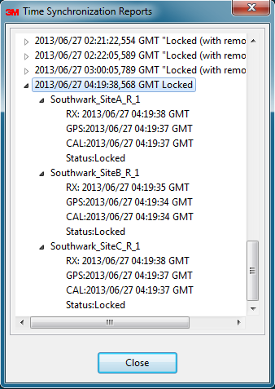

**Figure 9: Time Synchronization Reports**

# 3 Change Key Store

The final main function in VR-Viewer is to update the key store, which can be found under the “File” menu, as shown in Figure 10. Key Stores (in this case the keys between ERCU and VR-Viewer used to encrypt/decrypt the violation records) should be updated on a regular basis, at least annually. Refer to your Average Speed Camera System Administrator for a CD containing the updated Key Store. To load the new Key Sotre, the full path name of the new key store file must be specified as well as the pass phrase to access the key store to finish this operation. The VR-Viewer has backward compatibility with the key store, which means that any violation encrypted with an older or the same version of corresponding keys can be decrypted and shown on this VR-Viewer. Only violations which have been encrypted with a newer version of the Key Store than currently loaded in the VR-Viewer are not accessible.

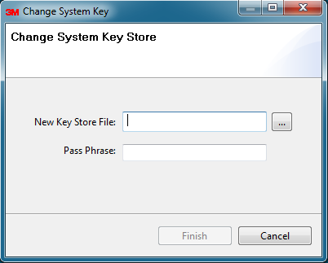

**Figure 10: Change Key Store**

# Appendix 1: Configurations in VR-Viewer

Some configurations can be set in the configuration file $VR-VIEWER/conf/Viewer.properties, which are shown as follows:

# Indicates the CR-ROM driver where the VR files are located vr.media.drive = D:

# Speed unit in the system, could be either MPH (miles per hour, default) or KPH vr.speed.unit = MPH

**Appendix 2: HardCopy example directly imported into Microsoft Word** ( VRN’s anonymised)

**Violation Record**

**Primary Record**

1cd0298a-65b5-441a-9fe5-

**Reference:**

42652c8446c2 **Violation Time:**

17/07/2009 11:27:09

GMT

**Link Name:** SouthwarkSpikeHDLinkBtoC **Link Certificate:** LNK4-1

**Corrected**

**Distance:** 0.775779 miles **Elapsed Time:** 00:01:14.222

**Primary Speed:** 37.628 MPH **Vehicle Plate:** Deleted

**Secondary Check**

**Uncorrected**

**Distance:** 0.778044 miles **Elapsed Time:** 00:01:14.214

**Secondary Speed:** 37.742 MPH

**Entrance Site**

**Site Id:** Southwark_SiteB_SpikeHD_1 **GPS Status:** Locked

**ANPR Read:** Deleted **Frame Counter:** 27513

**Session Id:** 199 **Event Id:** 4171

**Primary**

**Timestamp:** 17/07/2009 11:25:54.970 GMT

**Plate Patch:**

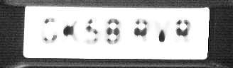

**Infrared Image:**

**Secondary Timestamp:**

17/07/2009

11:25:54.960 GMT

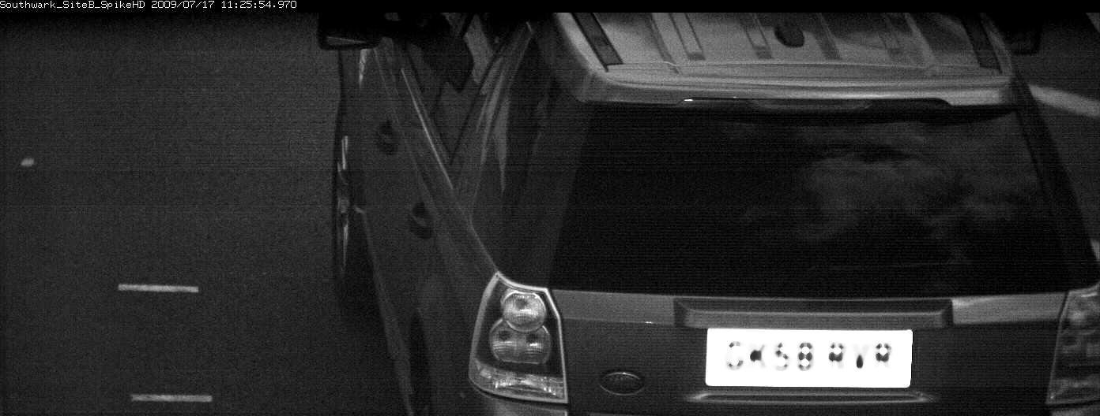

**Overview Image:**

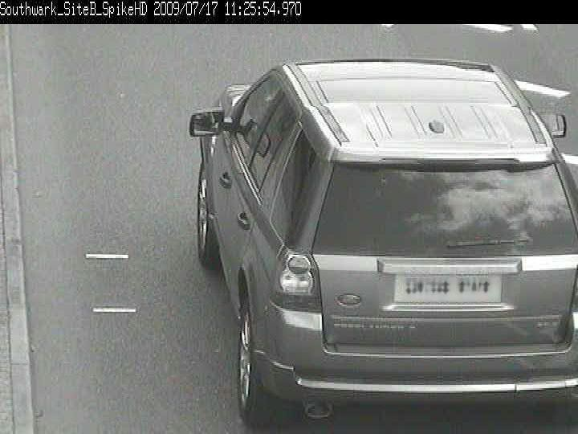

**Additional Contextual Image:**

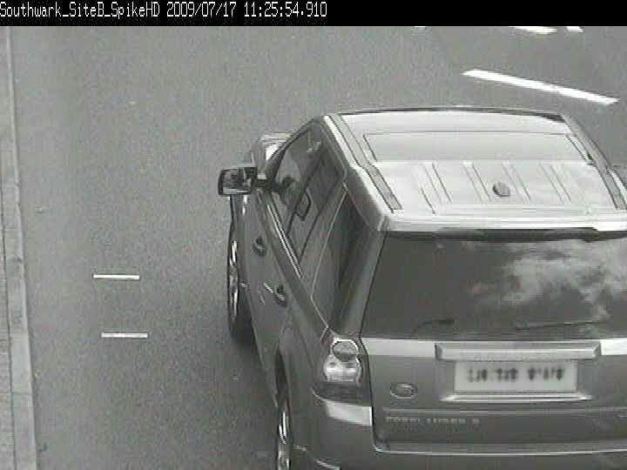

**Exit Site**

**Site Id:** Southwark_SiteC_SpikeHD_1 **GPS Status:** Locked

**ANPR Read:** Deleted **Frame Counter:** 28269

**Session Id:** 198 **Event Id:** 2344

**Primary**

**Secondary**

17/07/2009 11:27:09.174

**Timestamp:** 17/07/2009 11:27:09.192 GMT **Timestamp:**

**Plate Patch:**



**Infrared Image:**

GMT

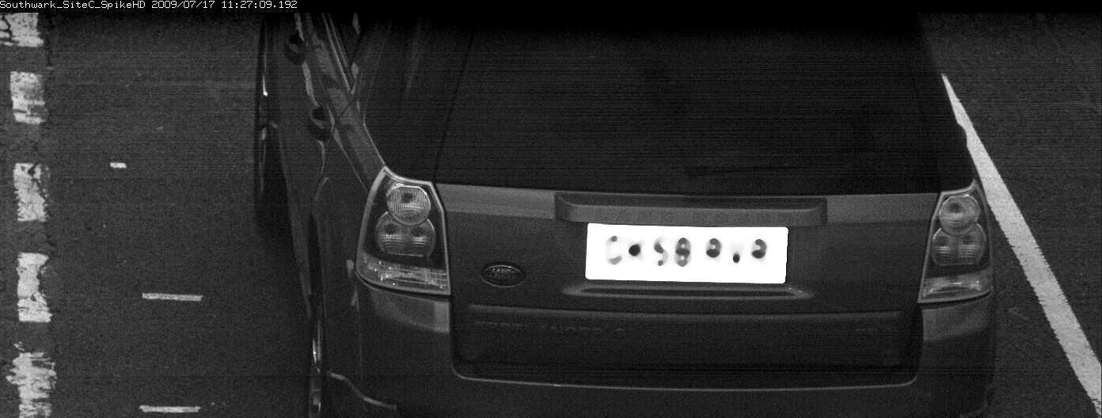

**Overview Image:**

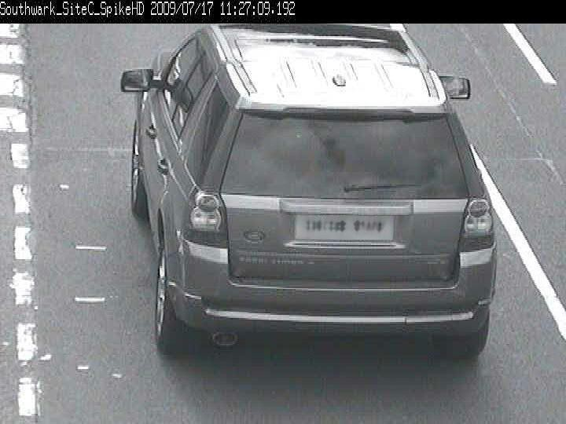

**Additional Contextual Image:**

